MAP admission report

This report presents an in-depth analysis of MAP admission scores and final test scores to identify if the benchmark of the MAP admission tests is sufficient enough, and to find any other trends or insights between the 2 tests. All student grades that were conducted in this analysis are hidden. The analysis is divided into 2 different categories which are students who took MAP admission tests in grade 10 and in grade 8, due to the difference benchmark for each MAP admission test. Each category has a few tests that were conducted. Due to the inconsistencies of the number of classes taken, all the Final grade scores that were used in this analysis are average. The first analysis test is the average of MAP scores compared to Final grade scores on each category. The Second tests are individual MAP scores which were “reading” and “math” compared to the Final scores. In this report there will be an explanation of each test as well as recommendations for teachers and educators. All the tests conducted in this analysis share the same independent and dependent variables, which are the MAP admission scores as the dependent variable and the Final grades as the independent variable, which questions how does the Final grade impact the MAP admission scores? This method is unconventional because students will have to take the MAP admission test first before they receive their final grades. By examining the relationship between Final Grades and MAP admission scores, we work backward to determine if the benchmark accurately reflects student performance. Note that currently the benchmark for grade 8 MAP admission score is 230 for both Math and Reading. For grade 10, Math is 249 and Reading is 228.

**Grade 8 Analysis on average MAP admission**

**Analysis**: The important values here are the coefficients, 159.6 and 10.6. The intercept which is 159.6 tells us that if a student's final grade is a 0, then their MAP scores would be 159.6 however if their grades increase the MAP admission scores will increase by 10.6, thus making this equation YG8 = 159.6 + 10.6(Students Final grade). Know that the number inside the bracket could range from 0-7 which is the grade boundaries for MYP and DP. The X variable coefficient shows us the change in MAP admission scores when a student’s Final grade changes. In general, if a p-value is below 0.05 it is considered statistically significance, what that means is that the value of the coefficients has an effect and not just by random chance. For the intercept p-value significantly below 0.05 meaning that it has an effect or has a causal relationship. The p-value for Final grade is a little higher than the threshold of 0.05 meaning that there are other variables that contribute but is not a part of this analysis.

The chart above shows a linear relationship between MAP admission scores and the final grade. However just by looking at the points, it is not a strong linear relationship, meaning A student who averages a high final grade does not always mean that their MAP admission scores are also high. An example would be a student who averages a 5.25 on their final grade with only 203.5 MAP admission score, however there are also a student who averages a 5 on their final grade but has a MAP score of 229 which is the second highest in the data set.

**Recommendation**: The entrance test benchmark is set a little too high at least for this grade. According to the analysis if a student scores an average 7 on their final grade, then their MAP score would be 159.6 + 10.6(7) = 234. The benchmark or the bar to pass this MAP exam is 230 which is just slightly below a student who averages a 7. This makes the benchmark really difficult to achieve. Just by looking at the raw numbers there are only 2 students who actually passed the benchmark. My personal recommendation is to use this analysis and figure out the new benchmark to pass, if SPH wants students that would achieve at least a 5 then 159.6 + 10.6(5) = 213 which should be the new bar to pass the admission.

**Grade 8 Analysis on each MAP admission scores (Math and Reading)**

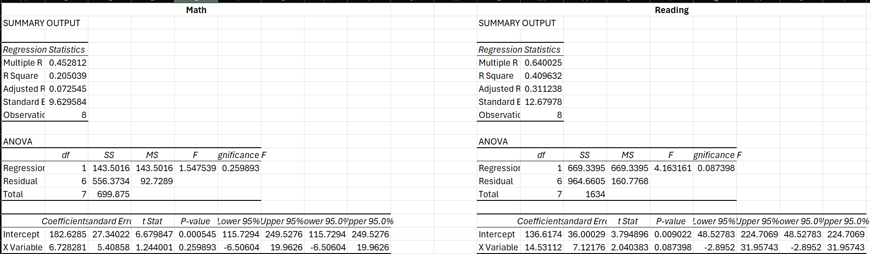

**Analysis**

**Math:** These are the tests that were run on MAP admission scores individually, so there are scores for Math and Reading. The table on the left side are the Math score results and on the right-hand side is the Reading score results. As for this analysis it is like the analysis above, the coefficients and p-value are the most important. As seen on the Math table that the intercept is 182.6 and the X variable is 6.7, thus making the equation as YMath8 = 182.6 + 6.7 (Students final grade). The range would be from 0-7 since it is the grade boundaries for DP and MYP. The p-value for the intercept is 0.0005 meaning it is statistically significant under the 0.05 threshold, thus making the intercept causal. However, the X variable’s p-value is 0.26 which is larger than 0.05 which means it is not statistically significant and is by chance that the number is 6.7.

**Reading**: On the Reading table the intercept coefficient is 136.6 and the X variable is 14.5 thus making the equation YReading8 = 136.6 + 14.5(Students Final grade). The p-value for the intercept is 0.009 which is statistically significant, however the X variable has a 0.08 p-value which is a little higher than the 0.05 threshold, and would be considered as not statistically significant.

**Recommendation**: The recommendations for this individual analysis would also be similar as the recommendations when MAP admission scores are averaged. An example would be for math, if we consider this equation, YMath8 = 182.6 + 6.7 (7) which indicates that the student’s Final grade is a 7 then the result of their MAP admission score would be 229.5 while the benchmark to get accepted is 230. For Reading the result would be YReading8 = 136.6 + 14.5(7) = 238.1 which is slightly above the benchmark at 228. Personally the benchmark to be accepted is too high, because if the benchmark doesn’t change then every student accepted should be averaging all 7’s which is not realistic.

**Grade 10 Analysis on average MAP admission scores**

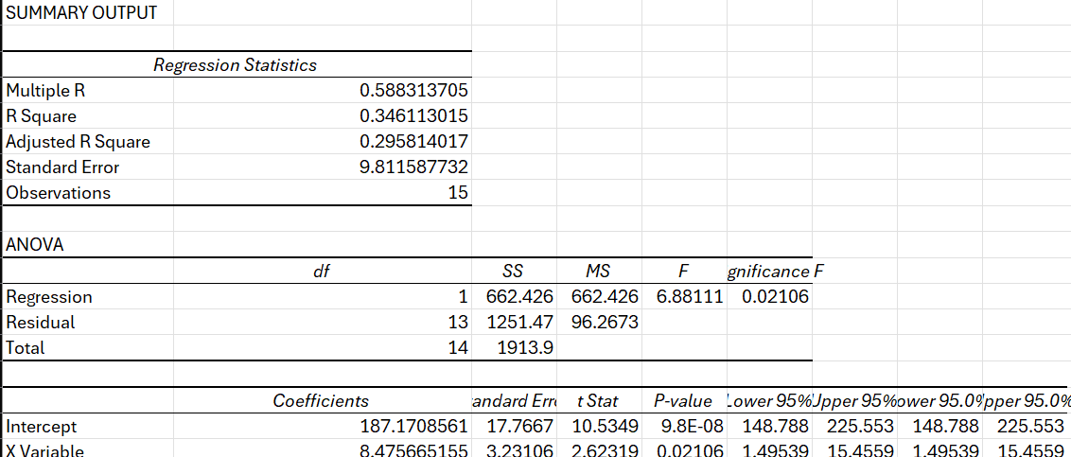

**Analysis:** This is the same analysis for Grade 8. The intercept is 187.2 and the coefficient for the slope or avg is 8.5. What this means is that if a student has an average score of 0 then their map scores would be 187.2, but if their final grade is a 5 then the equation would be YG10 = 187.2 + 8.47(5) =229.55. As mentioned on the previous analysis we are also interested in the p-value, as seen on the table the intercept p-value is 9.8 which is a very large number, what this means is that the intercept being 187.1 might just be by chance or is random, it is not statistically significance. This is due to various reasons, however for the slope or the change in MAP scores has a low p value, under 0.05 meaning that this is statistically significant.

In this chart above shows the R2 which indicates if there the 2 variables have a linear correlation, meaning that if a student who has a high DP final grade then the MAP admission scores should also be high, if this is true then the R2 would be very close to 1, however in this chart the R2 is relatively very low at 0.34. The chart shows that a student who has an average score of a 4 as their final grade does not always mean that their MAP admission scores would be less than 230. It can be proven from one the chart that a student actually averages a 4.1 final score but their MAP admission score is 237.5 which is relatively high. Another point that can be taken is a student who averages a 4.5 on their final grade but their MAP admission scores are 211.5, so a high final grades does not always mean a high MAP admission scores or vice versa. The chart shows that there is no strong linear correlation between the 2 tests.

**Recommendation:** In this test we can see that if someone averages a 7 their MAP admission score would be YG10 = 187.2 + 8.47(7) =246.7, if we average the MAP score then it would be (249+228)/2 = 239. So, if a student is averaging a 7 they would be above the benchmark. However, if a student is averaging a 6 then YG10 = 187.2 + 8.47(6) = 238, which is right on the benchmark. There are 15 student data that was given and from 15 only 5 was averaging a 6 or above meaning only 33.3% of students actually passed the benchmark. Personally, I would make the benchmark lower because 33.3% of students passing the benchmark is not realistic.

**Grade 10 Analysis on each MAP admission scores (Math and Reading)**

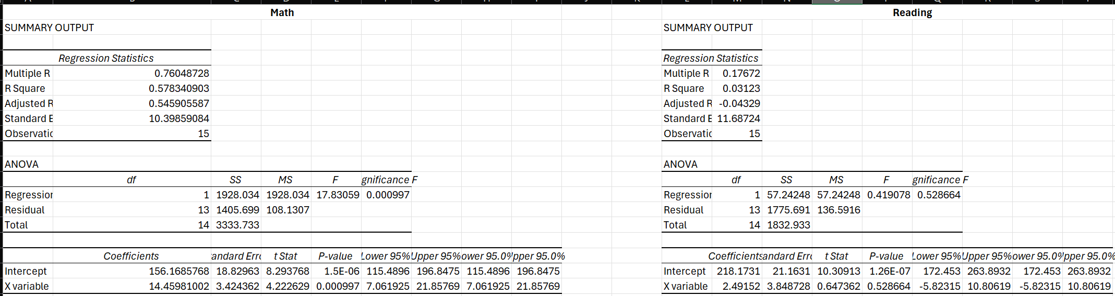

**Analysis**:

**Math:** Just like any other Analysis the coefficient and p- value are important. From the table above the math MAP scores have a correlation with student's final grades, it can be seen through the p-value for both the X variable and intercept which is well below 0.01 meaning it is statistically significant the equation would be YMath10 = 156.2 + 14.5(Student Final grade).

**Reading**: The coefficient intercept for reading is 218.2 and the X variable is 2.5 thus making the equation Yreading10 = 218.2 + 2.5(Student Final grade). However, for this particular analysis both of the intercept and X variable coefficients have a high p-value, much higher than the 0.05 threshold meaning that the final grades score does not have any causal relationship with MAP reading admission tests.

**Recommendations:** In this instance, it is difficult to give a recommendation because the reading analysis itself is not statistically significant in their intercept and X variable. However, the math scores have a strong causal relationship with the MAP admission scores. For grade 10 final grade it effects the MAP math scores while it almost has no effect on reading.

**Conclusion**

Most of the recommendations that were given are to lower the benchmark because mostly the benchmarks are equivalent to students having an average of 7 or 6 in their final grade. A lot of students that were accepted did not pass the benchmark, meaning that there are other qualitative reasons that made these students accepted. If SPH wants to make the MAP admission test more relevant to determine student’s acceptance then they should reduce the benchmark, to have a stronger reason for a student to be accepted. However, with lowering the benchmark it might compromise the quality of students’ intellectual capabilities.